

Mohammad Ali Jinnah University

Chartered by Government of Sindh - Recognized by HEC

**Assignment Software Process Models**

**Name:** Muhamad Fahad

**Id:** FA19-BSSE-0014

**Subject:** SCD (Software Construction and Development)

**Section:** AM

**Teacher:** Muhammad Tauseef

**Date:** Tuesday, March 16, 2021

Scenario

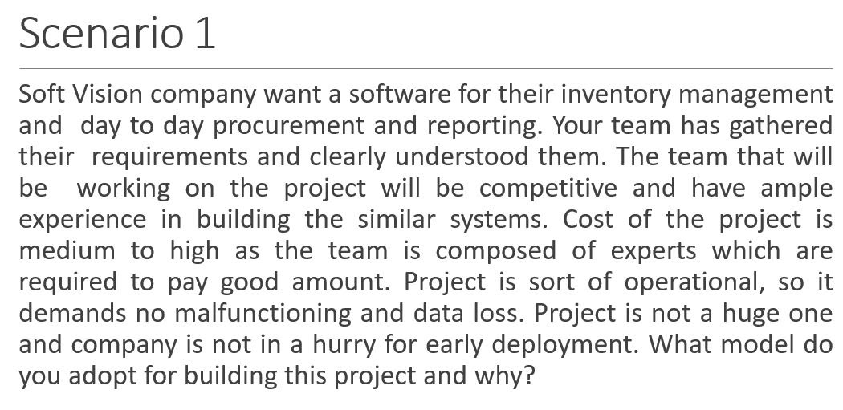

Answer: Waterfall modal

Reasons:

* Your team has gathered their requirements and clearly understood them.
* The team have experience in building the similar systems.
* Cost of the project is medium to high
* Project is not a huge one and company is not in a hurry for early deployment.

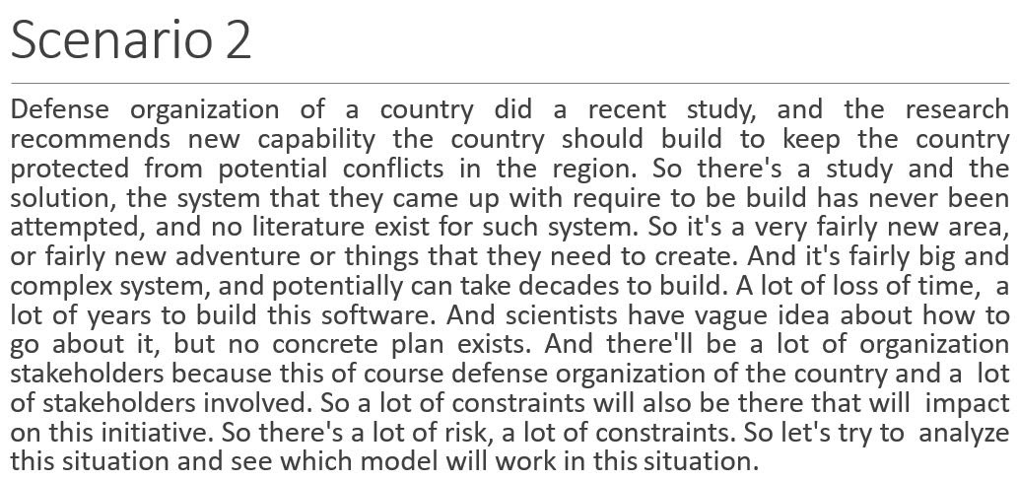

Answer: Spiral modal

Reasons:

* The solution, the system has never been attempted to build, and no literature exist for such system.
* It's fairly big and complex system, and potentially can take decades to build.
* A lot of loss of time, a lot of years to build this software.
* An idea about how to go about it, but no concrete plan exists.
* And there'll be a lot of organization stakeholders
* So there's a lot of risk, a lot of constraints